System Design of Competitive Programming Contest Platform

1. Questions

1.1 Type
1.1.1 MCQ
1.1.2 Quiz set on individual tops
Feature:
  - Time count on top
  - Correct answer if wrong
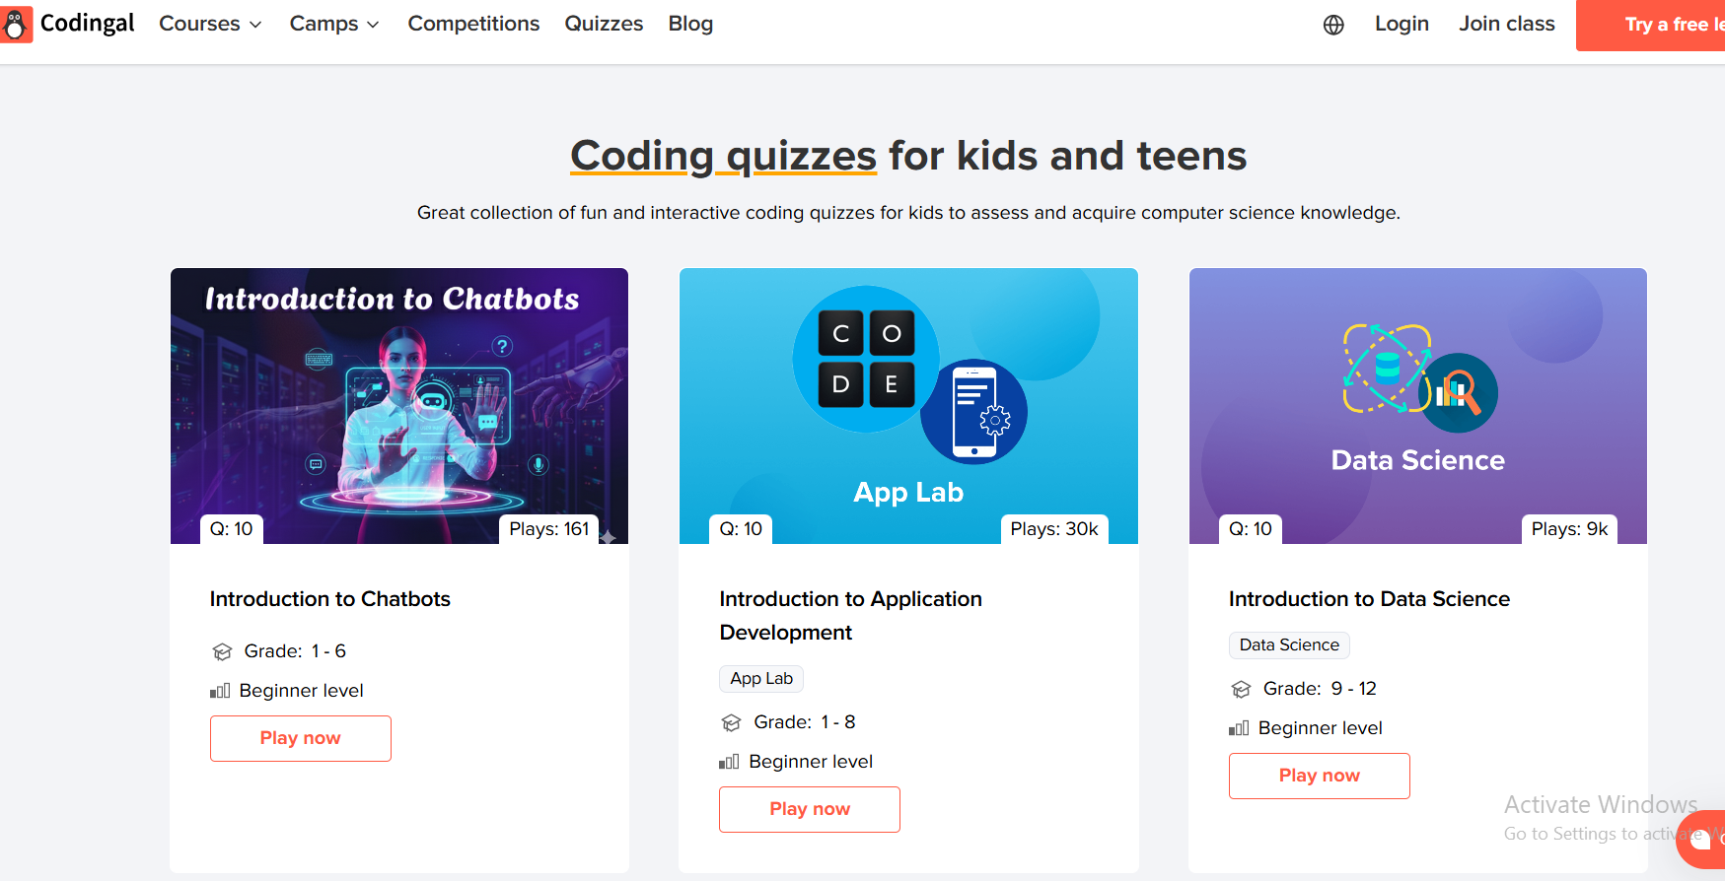
1.1.3. Coding questions

1.2 Level
1.2.1 Beginner
- conceptual
- small constraints
- step-by-step hints
1.2.2 Intermediate
- requires planning,
- moderate constraints
- algorithmic thinking
1.2.3 Hard
- contest-level,
- Optimization
- advanced DS & algorithms

1.3 Topic
1.3.1 Introduction (programming basics, problem statements)
1.3.2 Variables & Data Types
1.3.3 Loops & Conditionals
1.3.4 Arrays & Strings
1.3.5 Functions & Recursion
1.3.6 Sorting & Searching

1.4 Language
1.4.1 C
1.4.2 C++
1.4.3 Java
1.4.4 Python
1.4.5 PHP
1.4.6 JavaScript
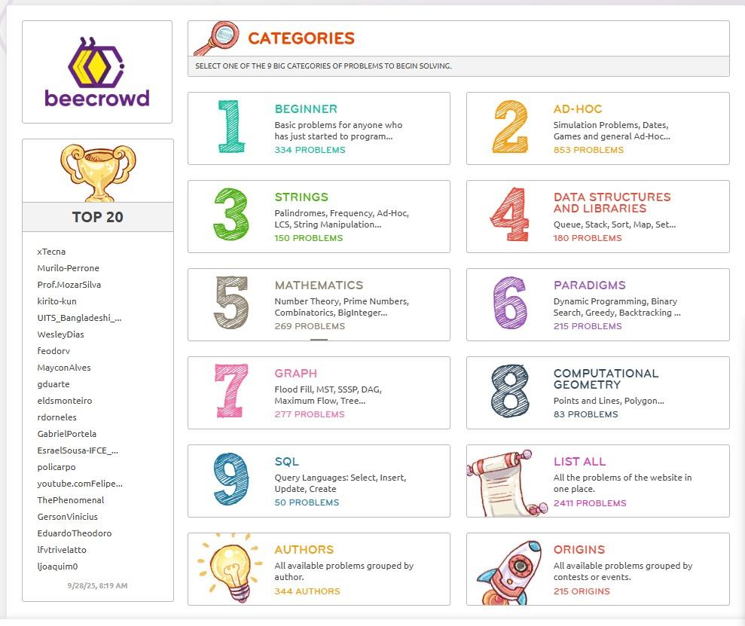

2. Papers for Practice

2.1 Topic wise

2.2 Level wise

2.3 Language wise

3. Solution Sets

3.1 Question Explanation
3.1.1 Tutorial
  - Step-by-step method:
    - Clear stages.
    - Logic explanation
    - Reasoning behind operations
  - complexity analysis
  - Visualized explanations

    - Diagrams
    - Charts
    - Illustrations.

3.1.2 Hints
  - progressive hint system (light → medium → strong).
  - Hints are gated by two possible ways:
- number of submission
- Time spent
3.1.3 Examples
- multiple sample I/O pairs with edge-case examples

3.2 Solution Explanation
3.2.1 Tutorial
  - conceptual breakdown
  - Pseudo-code
  - proof of correctness
3.2.2 Code Sample:
  - multi-language code templates (C, C++, Java) with comments and complexity notes available

3.3 Common Mistakes
- Shows common errors
  - Off-by-one
  - Overflow
  - wrong condition
  - Gives hints when many students fail the same test cases
4. Roadmap

4.1 Beginner Roadmap

4.1.1 Fundamentals
4.1.1.1 Programming basics
- syntax
- variables
- data types
- Operators
- conditionals
- loops
- functions
4.1.1.2 Tools & environment setup
- code editor
- terminal basics
- Git/GitHub
- install language runtimes
4.1.1.3 First small projects:
- Calculator App
- To-Do List

4.1.2 Core Concepts
4.1.2.1 Data structures:
- arrays/lists
- dictionaries/maps
4.1.2.2 I/O handling:
- reading/writing STDIN/STDOUT,
- parsing

4.1.3 Practice Projects
4.1.3.1 Mini games:
- Tic-tac-toe
- Number guessing
- Rock-paper-scissors
4.1.3.2 Public APIs:
- Weather
- Currency exchange
- Random quote generator

4.1.4 Recommended Videos/Docs
4.1.4.1 Official docs
4.1.4.2 Crash courses
- YouTube
4.1.4.3 Interactive tutorials
- W3Schools
- Codecademy

4.2 Intermediate Roadmap
4.2.1 Skill Expansion:
- OOP
- file handling
4.2.2 Applied Knowledge
- Databases
- REST APIs
- framework intros
4.2.3 Projects
- CRUD app
- Blog/Notes app
4.2.4 Resources
- framework official guides (Laravel, React)
- intermediate tutorials

4.3 Advanced Roadmap
4.3.1 Advanced Concepts:
- design patterns
- advanced algorithms (graphs, DP)
4.3.2 System-Level Skills
- architecture (MVC)
4.3.3 Advanced Projects:
- full-stack application
- distributed systems primer
4.3.4 Resources
- system design lectures and research papers

5. Profile

5.1 Personal Info
- Profile Picture (or avatar for kids),
- Username,
- Country,
- Student/Professional flag,
- Gender (optional),
- Email,
- Institution Name,
- Preferred Programming Language
- Privacy controls (kids: no public email or real photo by default)

5.2 Progress & Statistics
5.2.1 Submissions Heat Map
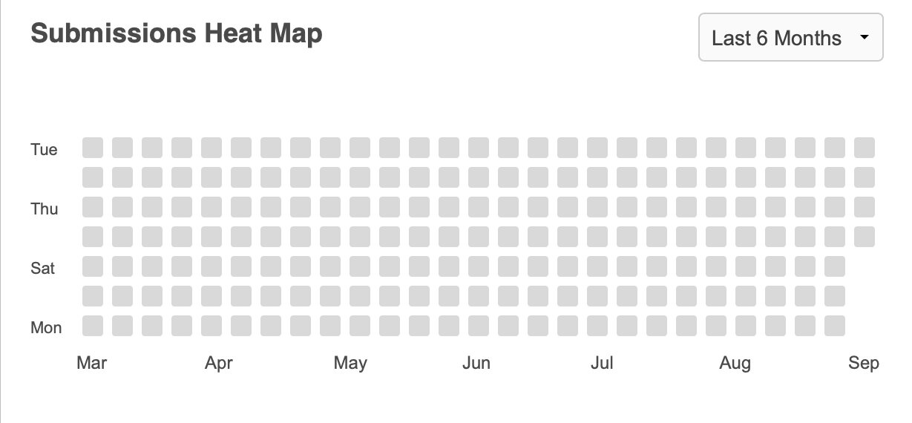
5.2.2 Learning Paths tracked & visualized
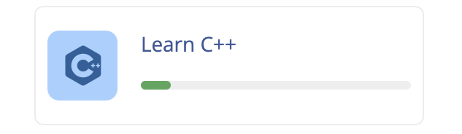

5.2.3 Practice Paths
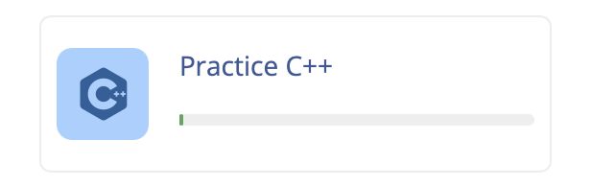
5.2.4 Contests: list and performance per contest
5.2.5 Total Problems Solved

5.3 Achievements / Badges
- Code Enthusiast – one budget (solve 10 problems)
- Contest Participant – one budget (attend 5 contests)
- Problem Solver — Bronze (solve 200 problems)
- Tiered Badges: Bronze → Silver → Gold → Platinum → Diamond → Master → Grandmaster
- Badge privacy & share options (social / certificate PDF)

5.4 Recent Activities
- Timeline of recent submissions,
- contest entries
- badges earned
- comment threads
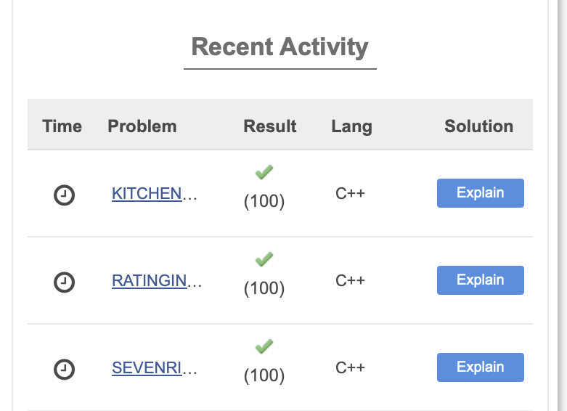
6. Study Plan

6.1 Daily Plan
- Warm-up (easy problems/quizzes)
- Practice (1–3 problems on the day's topic)
- Timed drill (1–2 contest-style problems)
- Review (read editorial, fix mistakes)

6.2 Weekly Plan
- Focus on 1–2 topics
- solve mixed problems
- take 1 full mock contest
- review unsolved

6.3 Monthly Plan
- Practice key algorithms
- 2–4 mock contests
- analyze strengths/weaknesses
- set new monthly goals
- team practice

6.4 Recommended Tasks
- Problem sets
- learning tasks
- project tasks

6.5 Progress Tracking
- Auto-adjusted suggestions and charts
- notifications for missed goals
7. Community

7.1 Announcement
- Platform-wide banners
- contest schedules
- update notes (moderated)

7.2 Discussion
- Topic forums,
- question threads with upvote/accept
- moderated replies
- Kids: moderated, no private 1:1 chat; only group/teacher channels
- Integrations: Discord-style server
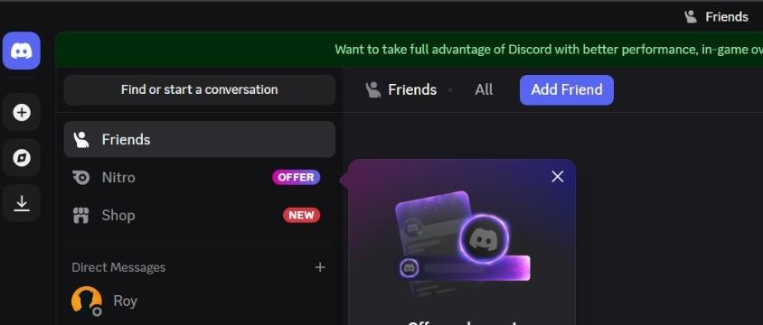
reference: https://discord.com/

7.3 Mentorship
- Mentor program (verified mentors)
- scheduled office hours
- live Q&A
8. Notification

8.1 Reminders
- Upcoming contest reminders
- daily practice nudges
- streak reminders
- study plan reminders

8.2 Event Notifications
- Upcoming/Ongoing events
- new editorials published

8.3 Achievement / Badge Notifications
8.3.1. Delivery Methods
- Push notification (mobile)
- In-app toast (appears briefly within the app UI)
- Optional email (user-controlled preference)
8.3.2. Special Handling for Kid Accounts
- Email notifications default to parent/guardian email for eligible notifications.
9. Streak

9.1 Daily Activity Tracking
- Track consecutive days of solved problems or active learning
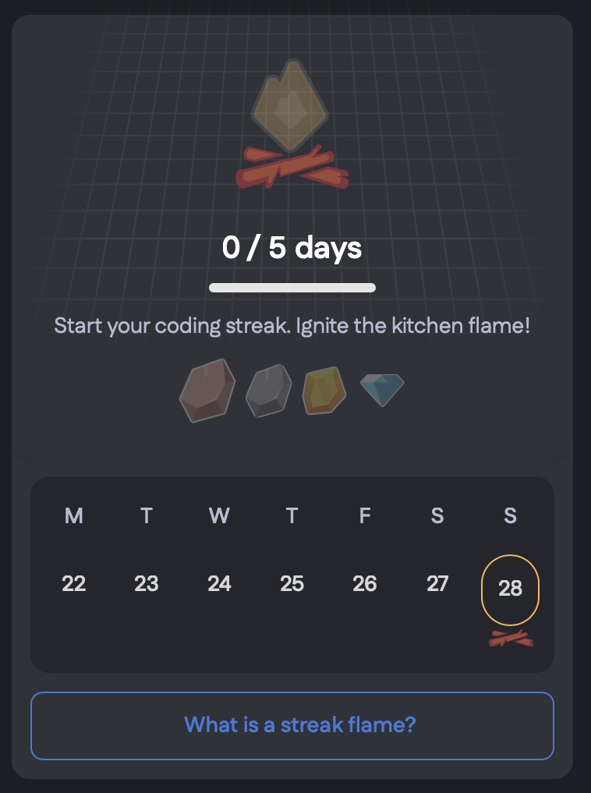

9.2 Streak Graph
- Visual weekly/monthly streak chart, reward thresholds configured by admin
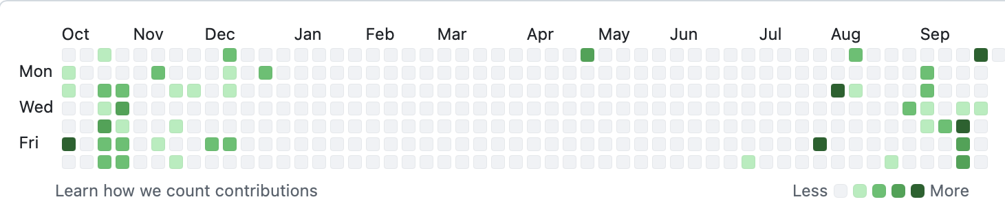
10. Event

10.1 Contest
10.1.1 Coding Contest
10.1.2 Bug-Fixing Contest
10.1.3 Hackathon
10.1.4 Quiz
10.1.5 Team Contests

10.2 Workshop
10.2.1 Beginner Workshops
- Intro to programming languages
- Git & GitHub basics
- Building first projects
10.2.2 Intermediate Workshops
- Web development bootcamps
- API building & integration
10.2.3 Advanced Workshops
- System design & architecture

10.3 Team Challenges
10.3.1. Debugging Marathon – Teams race against time to fix as many buggy programs as possible.
10.3.2. Code Collaboration Sprint – Teams work together to build a small project within a limited time.
10.3.3. Algorithm Relay – Each member solves a part of the problem and passes it to the next teammate.
10.3.4. Code Fusion – Different team members write modules separately and then integrate them into one working solution.
10.3.5. Competitive Debug & Test – Teams swap codes with another team and find as many bugs or test failures as possible.

11. Case Studies
11.1 Top Performer Stories
- Interviews: Talks with top achievers.
- Shared strategies: How they prepared and practiced.
- Tips & tricks: Useful advice for learners provided by top performers on the platform.

